**TRIGGER LAMBDA FROM S3 BUCKET AND COPY DATA INFORMATION IN DYNAMODB.**

1. **Create an S3 Bucket:** If you don't already have an S3 bucket, create one to hold the files you want to process.
2. **Create a DynamoDB Table:** Create a DynamoDB table where you want to store the data information. Define the schema with the necessary attributes.
3. **Create an IAM Role:** Create an IAM role that the Lambda function will assume to interact with both the S3 bucket and the DynamoDB table. Attach policies that allow the Lambda function to read from the S3 bucket and write to the DynamoDB table.
4. **Write the Lambda Function:** Write a Lambda function in your preferred programming language that handles the copying of data from S3 to DynamoDB.
5. **Configure S3 Event Trigger:** In the AWS Lambda console, create a new trigger for your Lambda function. Configure the trigger to be triggered by S3 bucket events, specifying the bucket name and event types (e.g., **ObjectCreated**).
6. **Test:** Upload a file to the S3 bucket to trigger the Lambda function. The Lambda function will then read the data from the uploaded file, parse it, and store it in the DynamoDB table.

**create IAM role and give full access to dynamodb in IAM**

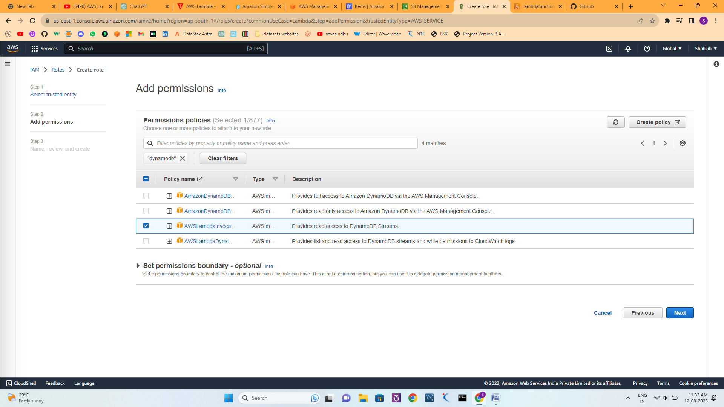

**Create on s3 bucket**

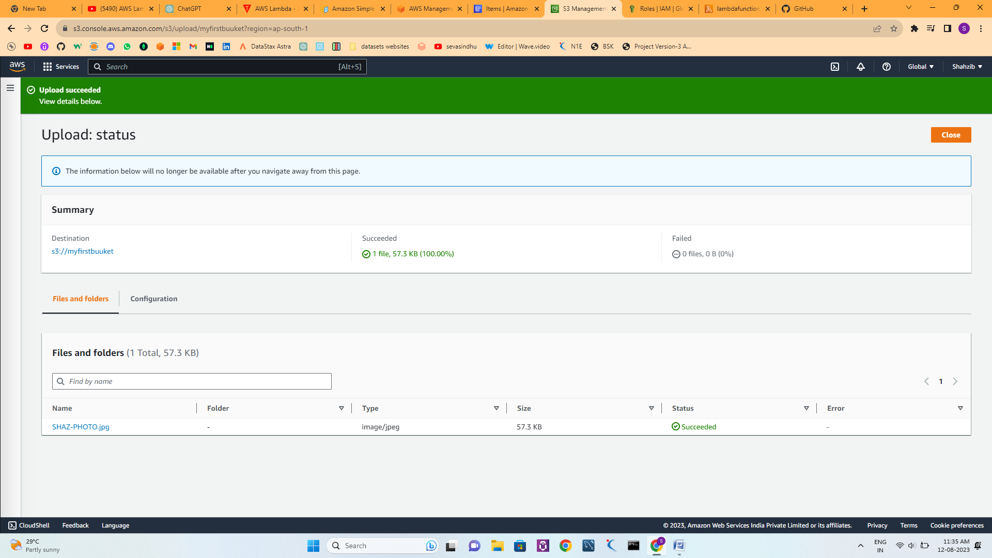

**Create one lambda function and trigger the s3**

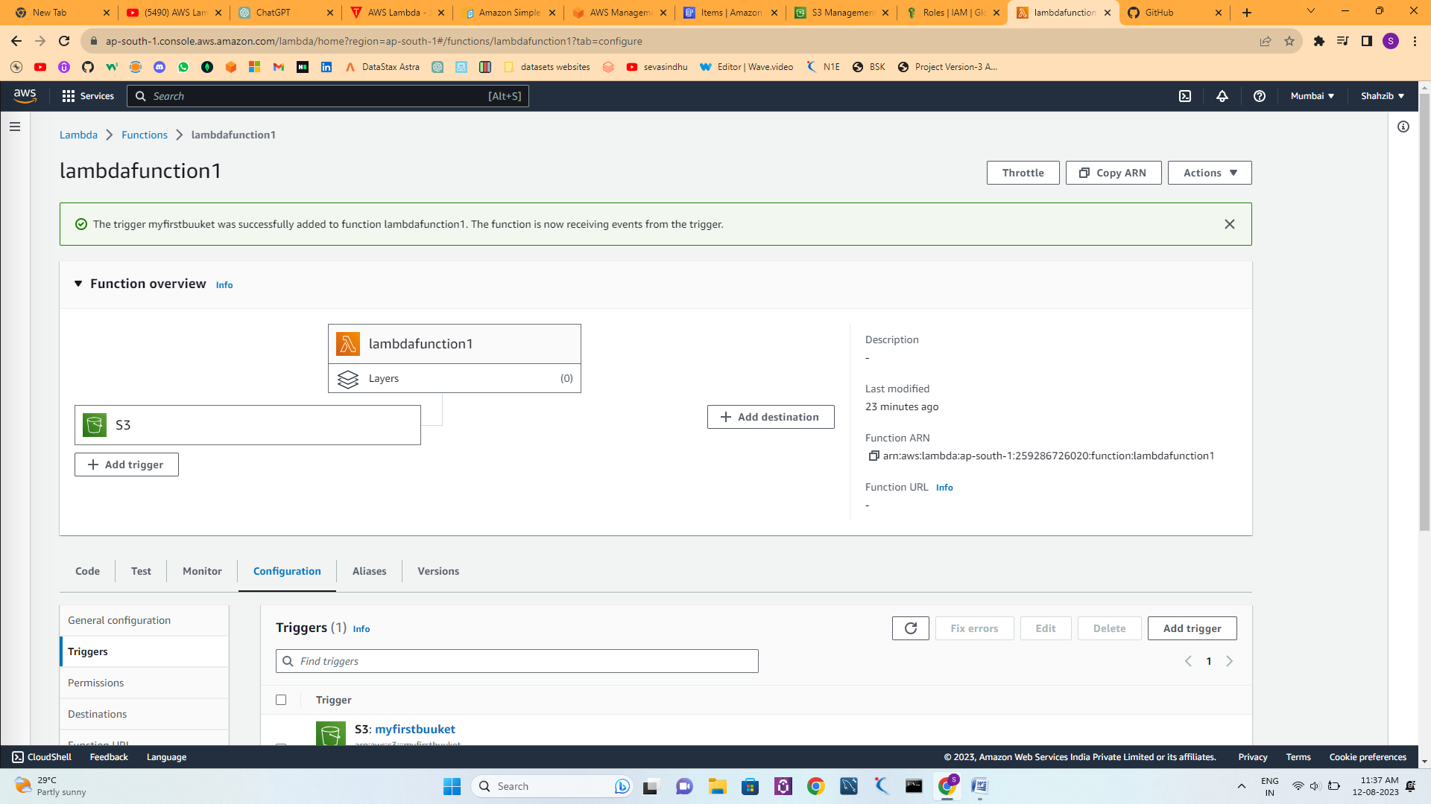

**Before trigerring write lambda function code**

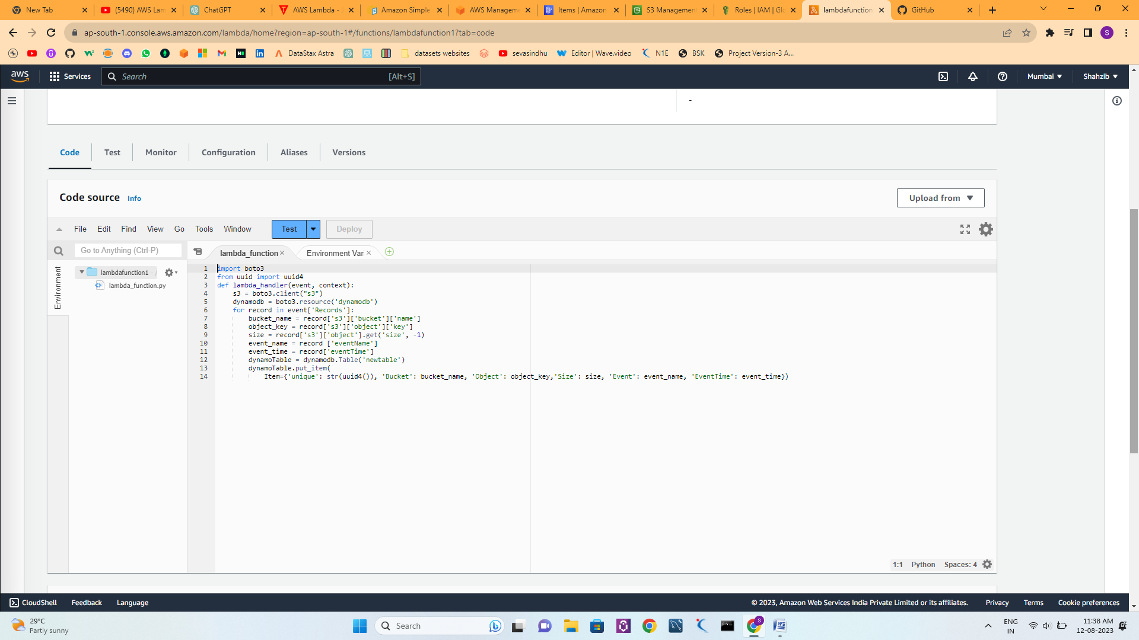

**Create table in dynamodb to write data when any functionshapen in s3**

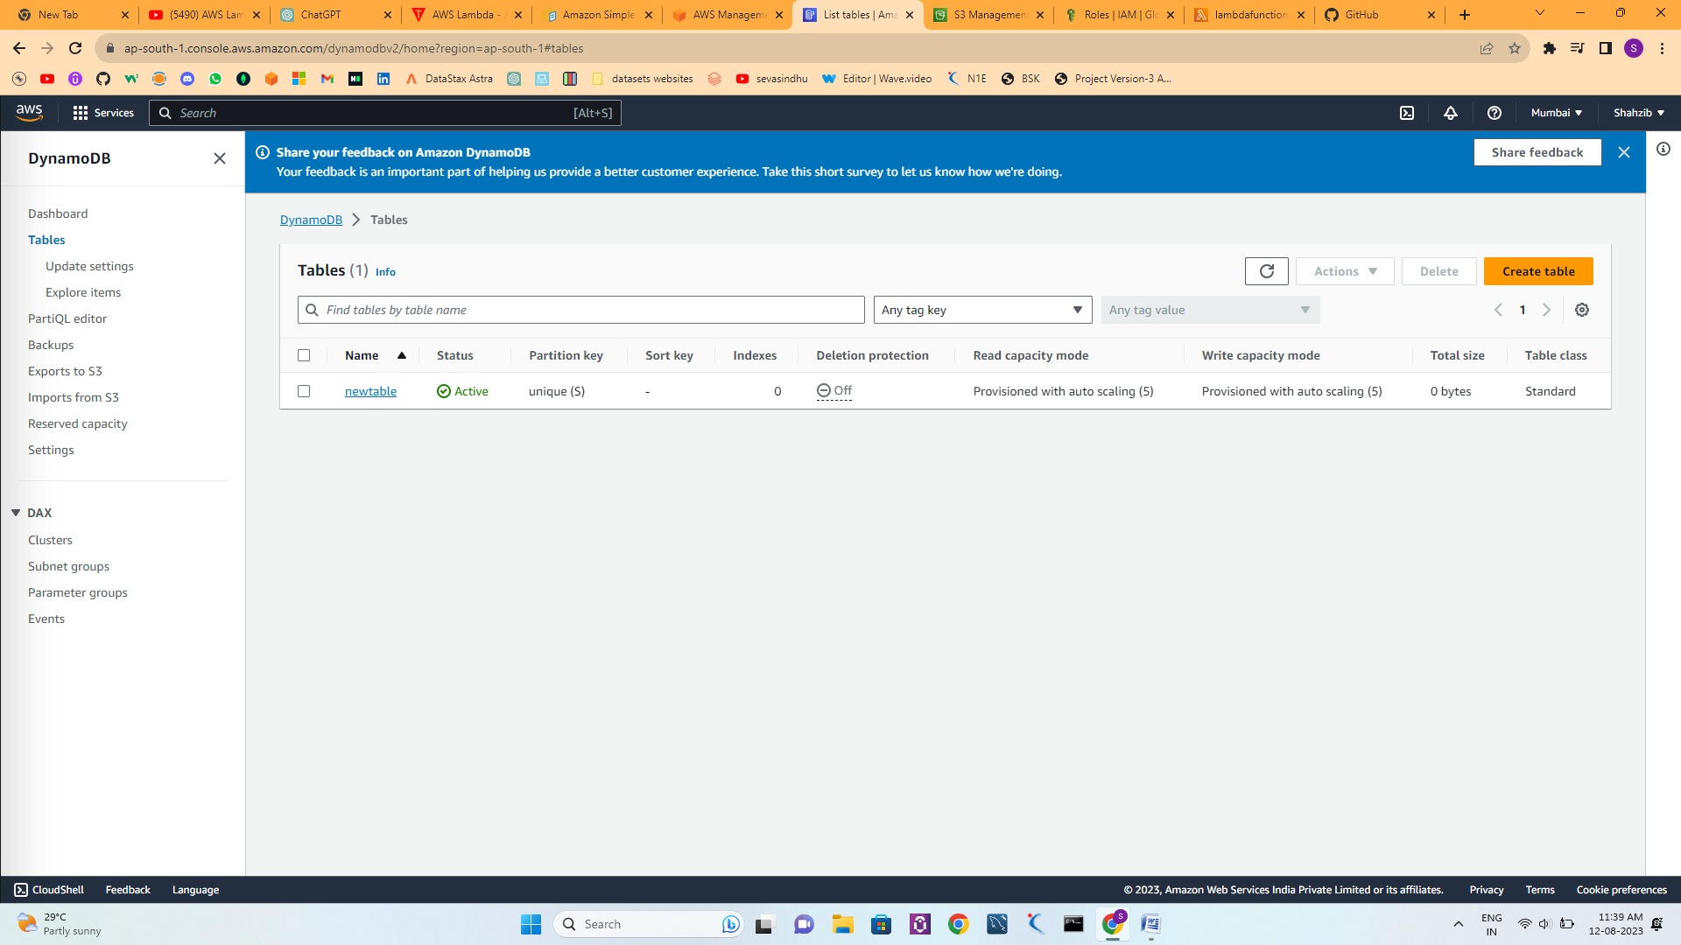

**Upload data in s3 bucket**

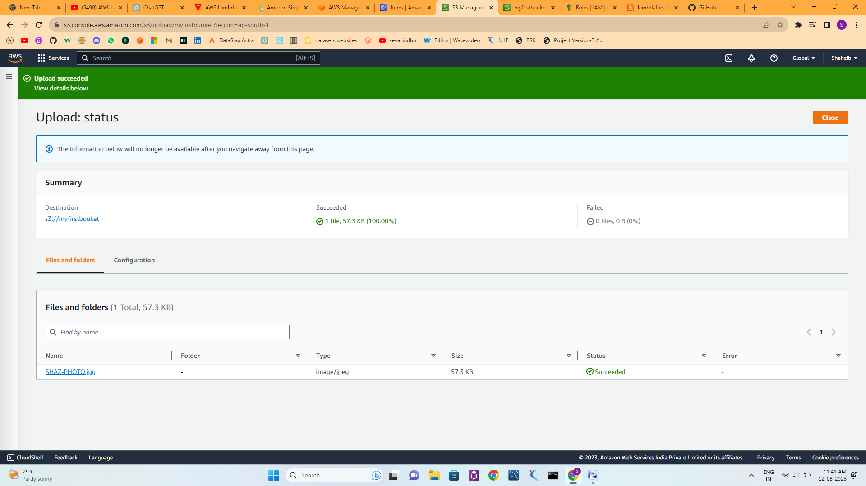

**Lets check the lamba function code has trigerred or not in the dynamdb**

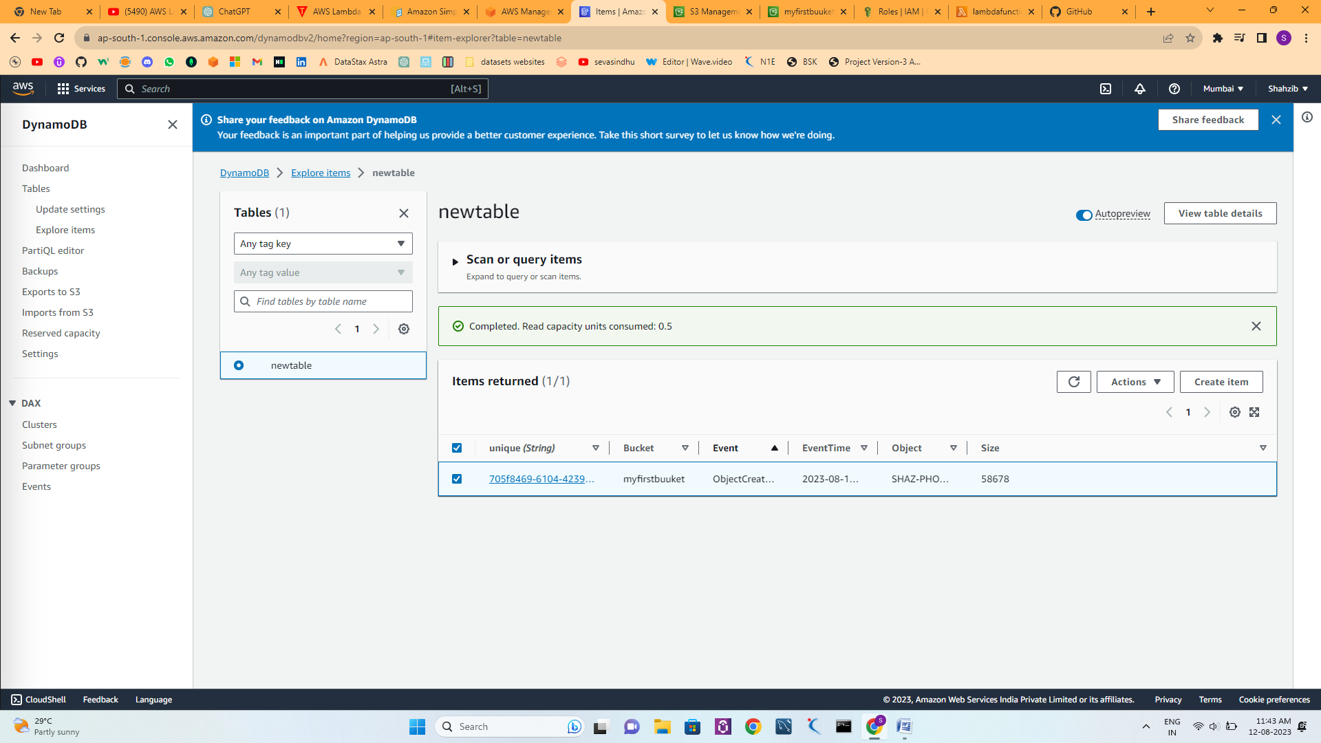

**Successfully data has written in dynamodb which contain event name,object,time,size uploaded in function code**